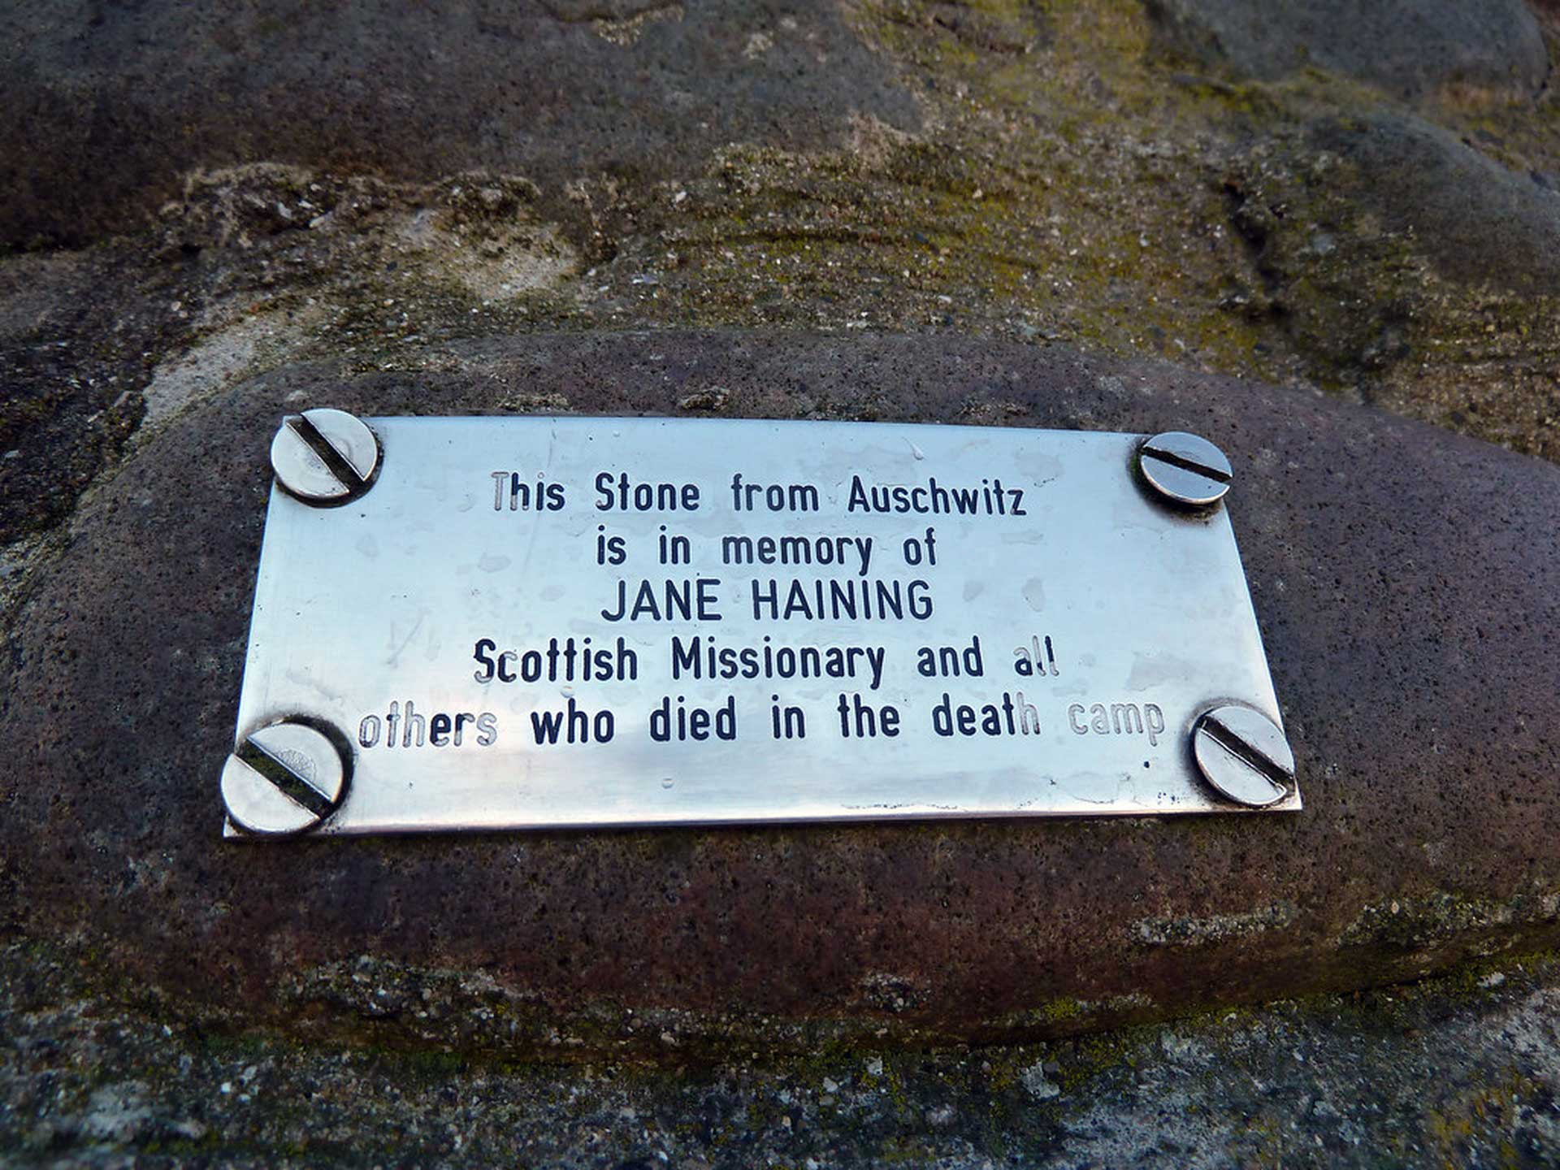

Faith in the Face of Darkness: The Legacy of Jane Haining
Faith in the Face of Darkness: The Legacy of Jane Haining
## Jane Haining: A Scottish Hero Who Helped Kids

Jane Haining was a kind Scottish woman who helped children in need. She was born in 1997 and grew up on a farm. She learned about Jesus at Sunday School and became a Christian; that is someone who loves and trusts in God, She aimed to be a good student and loved to help others.

Jane wanted to help people all over the world as she wanted to follow Jesus' example. She became a missionary and went to Hungary in 1932. She worked at a school for children, taking care of the kids who lived there.

Jane loved all the children, even when things got hard. She stayed at the school even when war broke out. She knew the children needed her, especially during those tough times.

Sadly, the war made things very difficult for Jewish people. They were forced to wear a yellow star on their clothes and were taken away to a bad place called Auschwitz. Jane was arrested because she helped the Jewish children.

When she was taken to Auschwitz, Jane was very brave and stayed strong even though things were scary. She had faith in God that this was what she was to do. She even sent a postcard to her friends asking for food.

Jane died at Auschwitz in 1944. She was only 47 years old. She was a hero because she helped children in need, even when it was dangerous.

People remember Jane for her kindness and bravery and also for her faith in God at all times. She is a reminder that even in the darkest times, we can show love for others, be kind and help others.

Reading Summary
- Jane Haining was a Scottish woman who helped children in need.
- She worked at a school in Hungary and stayed there even when war broke out.
- Jane was a hero because she helped Jewish children even though it was dangerous.

Vocabulary
Term | Definition |  | Example Sentence
missionary (noun) | A person who travels to a different country to teach people about their religion. |  | The missionary traveled to Africa to help people learn about Christianity.
Auschwitz (noun) | A very bad place where people were hurt and killed during World War II. |  | During the war, many people were sent to Auschwitz.
arrested (verb) | To be taken to jail because you did something wrong. |  | The boy was arrested for stealing a toy from the store.
brave (adjective) | Not afraid to do something even if it is scary. |  | The firefighter was brave when he went into the burning building.
hero (noun) | A person who does something very good and helpful. |  | The firefighter was a hero for saving the people in the burning building.

Multiple Choice Questions
Question #1 |  | Question #2 |  | Question #3
What did Jane Haining do to help the children at the school? |  | Why did Jane Haining get arrested? |  | What happened to Jane Haining at the end of the story?
A. She played games with them.  B. She helped them with their schoolwork.  C. She took care of them and made sure they were safe.  D. She taught them how to sing. |  | A. She broke a rule at the school.  B. She was caught stealing.  C. She helped Jewish children.  D. She was sick and needed to go to the hospital. |  | A. She went back to Scotland.  B. She became a teacher.  C. She died at Auschwitz.  D. She got married and had a family.

Short Answer Questions
Question #1 | Where did Jane Haining grow up?
__________________________________________________________________________________________________________________________________________________________________________________________________________________________________________________________________________________________________________________________________________________________________________________
Question #2 | What did Jane Haining do before she became a missionary?
__________________________________________________________________________________________________________________________________________________________________________________________________________________________________________________________________________________________________________________________________________________________________________________
Question #3 | What did Jane Haining do to help the Jewish children during the war?
__________________________________________________________________________________________________________________________________________________________________________________________________________________________________________________________________________________________________________________________________________________________________________________

Open Ended Questions
Question #1 | Think about a time when you helped someone in need. How did you feel? What did you learn from that experience?
__________________________________________________________________________________________________________________________________________________________________________________________________________________________________________________________________________________________________________________________________________________________________________________
Question #2 | Jane Haining was brave and kind, even when things were hard. What are some ways you can be brave and kind in your own life?
__________________________________________________________________________________________________________________________________________________________________________________________________________________________________________________________________________________________________________________________________________________________________________________
Question #3 | Imagine you are a friend of Jane Haining. What would you say to her to thank her for helping the children?
__________________________________________________________________________________________________________________________________________________________________________________________________________________________________________________________________________________________________________________________________________________________________________________

This Diffit resource was created by Lynn MacMillan

